Jobs Management System

User Specifications

Developed for Circle Signs/Rhino Linings Rustenburg

Developed by: A. Prinsloo, F. Prinsloo

Contents

1. Description 3

2. Scope 3

3. Architecture 3

4. Data Model 4

4.1. Data tables 4

4.2. Statuses 5

5. System Workflow 7

5.1. Diagram 7

5.2. Business rules 8

5.3. User groups, roles 8

5.4. Dashboards and reports 8

6. User Forms 9

6.1. Quotes 9

6.2. Quote Details 9

6.3. Jobs 10

6.4. Job details 10

6.5. Employees 11

6.6. Employee details 11

6.7. Departments 11

6.8. Customers 11

6.9. Products 11

7. Development Process 12

7.1. Main components 12

7.2. Timelines 12

7.3. Terms 12

8. Agreement 12

# Description

The Jobs Management System (JMS) is used to handle quote creation and distribution and managing of jobs. The system keeps records for these quotes and jobs including job history for job management. It uses intuitive workflows to guide user interaction.

# Scope

The system manages quotes and jobs including job history.

The system allows for creating new quotes or to copy an existing quote. A quote can have more than one line item and includes functionality for sending the quote to the customer via e-mail. Jobs can be created from a quote where one line item on the quote represents one job.

History is recorded for each job to record its progress. A job status is set for each stage in the workflow and includes open, assigned, Pending, In Progress, completed and closed. The system keeps history of every action, with action dates, department, and owner.

For the system to function effectively additional information is required. This includes records for products, customers, employees, and departments.

Report included is “Open jobs” view indicating customer, job start date, and latest progress history.

# Architecture

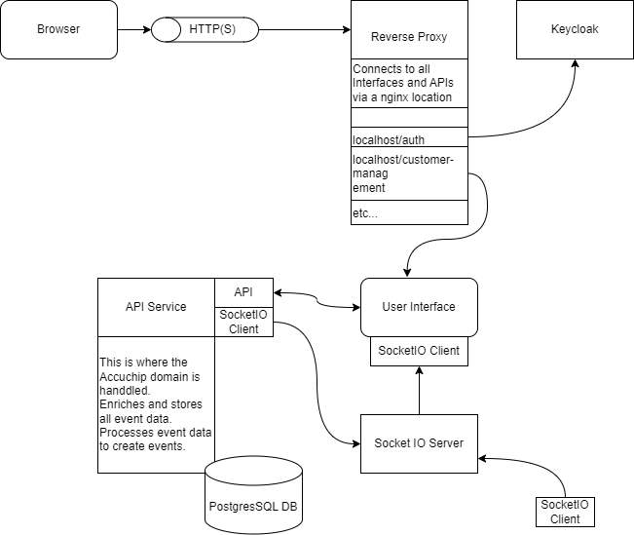

# Data Model

## Data tables

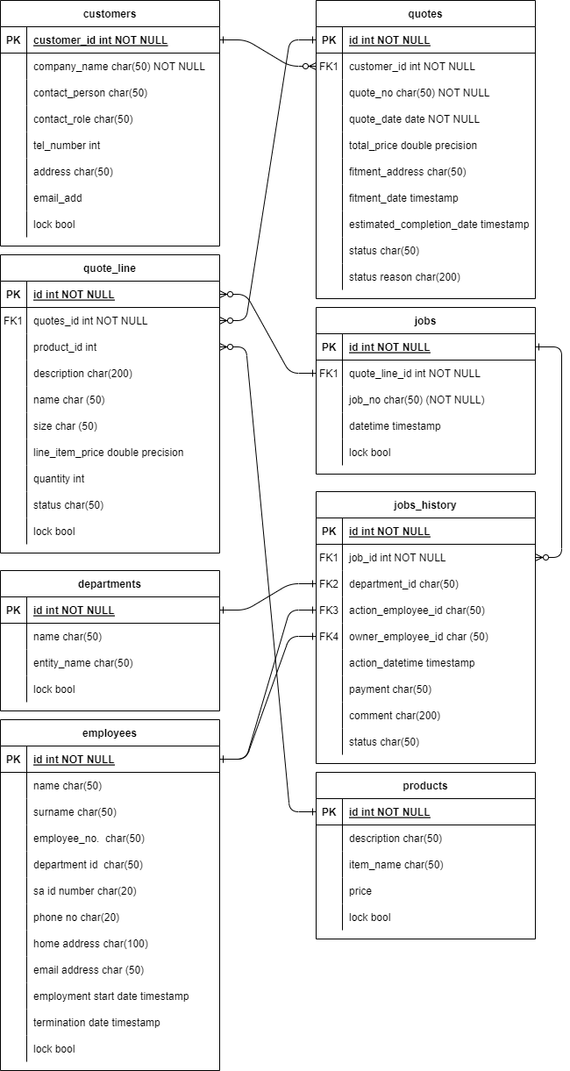

## Statuses

### Quotes

|  |  |  |
| --- | --- | --- |
| **Name** | **Description** | **Trigger** |
| Open | The quote was created and saved. Not send to customer yet and no jobs created | User press buttons: Save, Print or Copy (the new quote will have this status) |
| Sent | Quote was sent to customer | User press button: Send |
| Abandoned | No jobs were created (indicating customer did not accept quote) after 90 days (thus when all quote_lines are still in New status) | System workflow [3] orUser press Abandon button |
| Activated (partial) | Some of the line items on the quote was converted to jobs | User selected jobs and press button: Create Jobs |
| Activated | All the line items on the quote were converted to jobs | User selected all jobs and press button: Create Jobs |
| Closed | All quote lines have a Completed status | System Workflow [2] |

### Quote line

|  |  |  |
| --- | --- | --- |
| **Name** | **Description** | **Trigger** |
| New | When the line item is added to the quote | User press New Line button |
| On Job | A job was created for the line item | The user selected the line item and pressed the Create Jobs button |
| In Progress | job history status is in progress | User press Accept button |
| Completed | The job linked to the line item has a Closed status | System workflow [1]The line item cannot be deleted anymore |

### Job History

|  |  |  |
| --- | --- | --- |
| **Name** | **Description** | **Trigger** |
| Open | When a job is created the first time | User press Create Jobs button |
| Assigned | The job is assigned to an employee | User press Assign button |
| In Progress | An employee accepted the job assigned to him | User press Accept button |
| Pending | The job is on hold, reason was supplied by user | User press Pending button |
| Completed | The job was completed successfully | User press Completed button |
| Rework | The job could not be closed due to inspection not passed. | User press Rework button |
| Closed | The job was inspected and confirmed to be completed successfully | User press Close Job button |
| Cancelled | The customer cancelled the job before it incurred any costs, Delete button only available up to Assigned status | User press Delete button |

### Note system workflows order of priority follow numbers in square brackets [ ]

# System Workflow

## Diagram

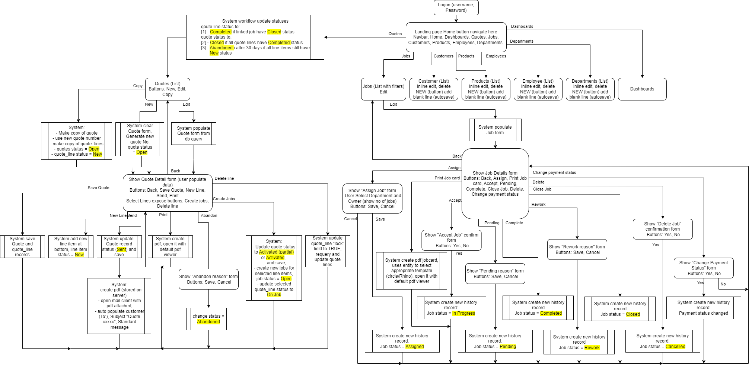

## Business rules

### Each line item on the quote represents a job, thus the quote must be constructed to support this.

### Quote date is populated automatically when the “Send” button is pressed.

### Copy function for closed quotes to copy an existing quote with new quote number.

### The system will change the quote status to “closed” when all jobs linked to the quote is in a closed status.

### Pressing “create jobs” is an action that verifies the customer’s acceptance of the quotation. Jobs details cannot be changed after customer acceptance.

### A job must be assigned before the job card is printed.

### Jobs assigned to employees through push action (allocated status). Jobs accepted by employees through pull action (in progress).

### Jobs can be put on hold by placing it in a “Pending” status. A reason must be captured when setting this status.

### When a job is finished the owner “Complete” the job on the system. When a completed job is inspected/delivered it must be “closed” on the system.

### Jobs can be “Deleted” when a quote was accepted but the customer cancelled to request. This changes the job status to “cancelled”. A job can not be deleted once assigned to an employee.

### The system uses the entity field to create the required pdf job card.

## User groups, roles

|  | Function | System admin | Reception | Management | Supervisor |
| --- | --- | --- | --- | --- | --- |
| Quotes | New Quote | X | X | X |  |
| Edit Quote | X | X | X |  |
| Copy Quote | X | X | X |  |
| Quote | New Quote Line | X |  | X |  |
| Send Quote | X |  | X |  |
| Create jobs | X | X | X |  |
| Save Quote | X | X | X |  |
| Jobs | Edit | X | X | X | X |
| Job Details | Assign | X | X | X | X |
| Accept | X | X | X | X |
| Pending | X | X | X | X |
| Complete | X | X | X | X |
| Close (closed status) | X | X | X | X |
| Employees/ Customers/ Departments/  products | New | X | X | X |  |
| Delete | X | X | X |  |

## Dashboards and reports

### Open jobs - Table

* Job No
* Customer
* Days outstanding
* Department
* Owner
* Status = open
* Comment

### Calendar

* Show Job no, customer, from fitment date to estimated completion date

### Completed jobs per week

* Graph, Pie chart - Employee jobs completed per week

# User Forms

## Quotes

* List all quotes in system using columns: Quote No., Customer, Date, Status
* Each item in list can be edited or copied (copy function to populate quote number customer and contact information, status = open, and copy each line item)
* user can filter using search
* a new quote can be created

## Quote Details

* Displays fields relating to the quote:
  + Quote No. (locked)
  + Quote Status (locked)
  + Date (locked, populated when quote is sent)
  + Customer (drop down list)
  + Contact person (editable dropdown list)1
  + Tel No. (populated when contact person is selected from drop-down, but still editable)[1]
  + e-mail (populated when contact person is selected from drop-down, but still editable)1
  + fitment address (editable)
  + fitment date (editable)
  + estimated completion date (editable)
  + Sub total (calculated from total prices)
  + 15% vat (calculated from sub total)
  + Total (calculated from sub total and vat)
  + Deposit (editable)
* line items list showing columns:
  + select box,
  + Qty (editable),
  + Name (dropdown from products table),
  + Description (populated when name is selected from drop-down, but still editable),
  + Size (populated when name is selected from drop-down, but still editable),
  + Price each (populated when name is selected from drop-down, but still editable),
  + Total price (calculated from price each and qty),
  + Status (locked)
* Buttons to:
  + Save the quote
  + add new line item
  + Send the quote to the customer
  + Print the quote
  + abandon the quote (user to provide reason)
  + delete a selected line item
  + create a job for selected line items

## Jobs

* List all open jobs in the system using columns: Job No., Customer, Contact person, Start date, owner, status
* Each item in list can be edited
* user can filter using search

## Job details

* Displays fields relating to the job:
  + Job number (locked)
  + Start date (locked)
  + Customer (locked)
  + Contact person (locked)
  + Contact number (locked)
  + Fitment address (locked)
  + Estimated completion date (locked)
  + Payment status (dropdown list)
  + Job description (locked)[2]
* Buttons to:
  + assign the job
  + print a job card (exposed after job was assigned)
  + accept a job (exposed after job card was printed)
  + place job in pending (exposed after job was accepted)
  + complete a job (exposed after job was accepted)
  + change job to rework status (exposed when job was completed), user enter reason for rework
  + close a job (exposed after job was completed)
  + delete a job (only exposed when job status is open or assigned)
* History list showing columns (all locked):
  + Date
  + Actioned
  + Department
  + Owner
  + Job status
  + Payment status

## Employees

* List all employees in the system using columns: employee No., name, surname
* a new employee can be created
* each item in the list can be edited or deleted

## Employee details

* Displays fields relating to the employee:
  + Employee number (auto populate)
  + Name (editable)
  + Surname (editable)
  + Department (dropdown list from departments table)
  + SA id number (editable)
  + Phone number (editable)
  + Home address (editable)
  + Email address (editable)
  + Employment start date (editable)
  + Termination date (editable)

## Departments

* List all departments in the system using columns: entity name, department name
* a new department can be created
* each item in the list can be edited in line
* each item in the list can be deleted

## Customers

* List all customers in the system using columns: company, address, contact person, tel no, e-mail, role
* user can filter using search
* a new customer can be created
* each item in the list can be edited in line
* each item in the list can be copied or deleted (copy function copies company and address, user to populate rest of the fields)

## Products

* List all products in the system using columns: product name, description, price
* user can filter using search
* a new product can be created
* each item in the list can be edited in line
* each item in the list can be deleted

# Development Process

## Main components

### Reverse proxy

### Role Mapping

### Front end (UI)

### Server setup (socket IO)

### API service

### Database (PostgreSQL)

### Data migration – products, customers

### After deployment Support (remotely for 6 months)

## Timelines

2 months (End March 2024)

Free Support – 6 months after go live, including three additional dashboards/reports

## Terms

50% dep (R6k + R6k)

50% after implementation (R12k)

# Agreement

I hereby agree with the specifications to be delivered, timelines and terms describe in this document.

|  |  |  |  |
| --- | --- | --- | --- |
| Customer name: |  | Signature: |  |
| Date: |  |  |  |

1. Update data table on save, print, send
2. Concatenate description fields of all quote lines linked to this job